IOT Car Security

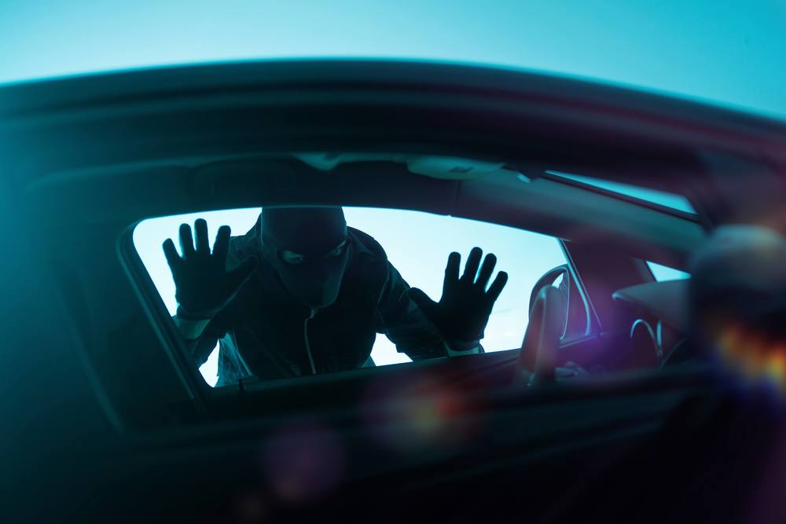

TECHNICAL APPROACH

The IOT Car Security System is designed using the following parts:

* Raspberry Pi 3B+
* Python
* OpenCV → library for image processing and computer vision.
* USB 4 Port Hub
* USB to TTL Serial Adapter \* 2
* WIMAXIT External Touchscreen Monitor,15.6 Inch Ulta-Slim 1920x1080 16:9 Display Type-C/USB C Monitor
* M5Stack ESP32
* LoRa REYAX RYLR896 Transceivers \* 2
* Android Cellular Phone API 23+ (At Least Marshmallow or newer) \* 2
* SG90 Servo
* Adafruit Ultimate GPS
* Adafruit Vibration Sensor switch.
* Logitech 920 Camera

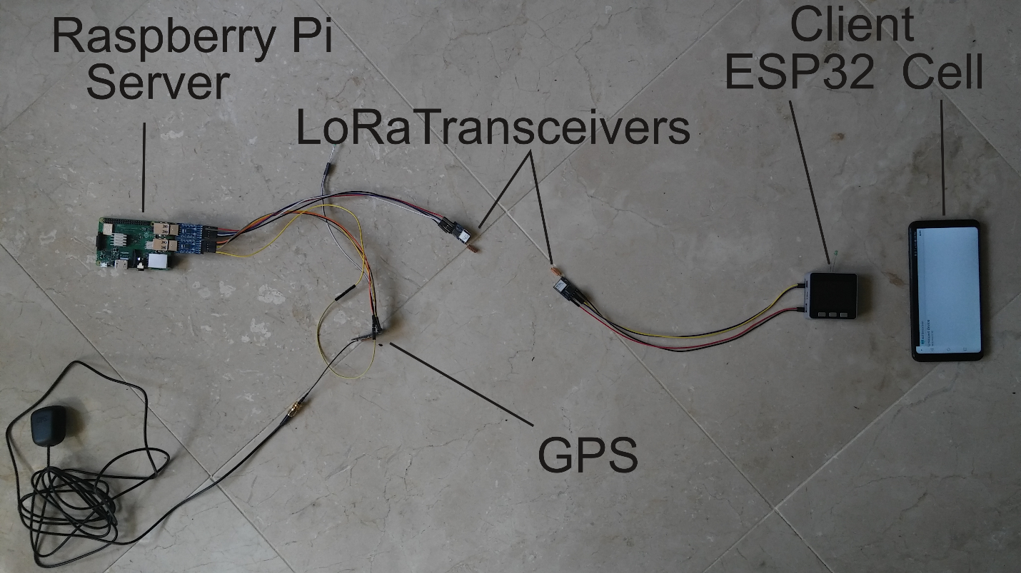

USB to TTL Serial adapters simplify testing, increase component modularity.

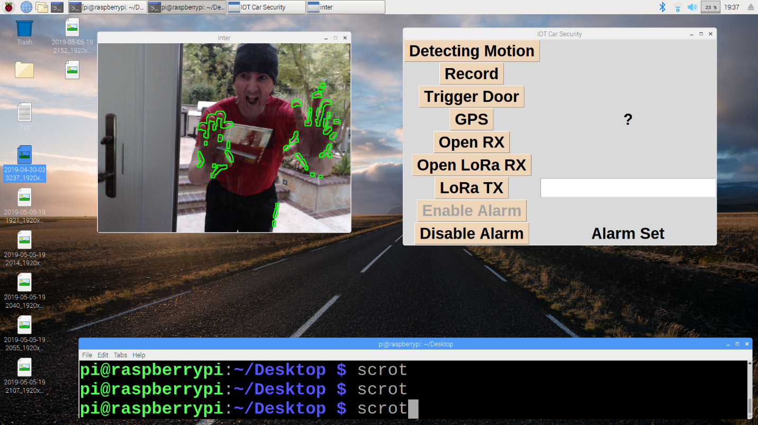

This image shows the 'contours' differences between frames.

So as a object moves these highlights tend to form a contour around the moving object.